ManuConnect Release - 2020.11.30
Release Date | 30 Nov 2020
Core Installer | 7.0.01130.677
Installer Suite | 7.0.01130.1020

Overview
Today's code drop includes Transaction Register user interface fixes and VO API changes.

Defects Addressed
Feature | Client No. | Category | Summary | Release Notes
MLU-850 | 2597 | Accounting | [CDTASME-2597] ASO BAR and client billed is showing in the TC under account setup and should only show MLI billed | Changed the Add Account screen to allow adding of MLI Billed account only.
MLU-845 | 2593 | Admin GUI | [CDTASME-2593] Fixes required to the TR and the PAD screens | Resolved drop-list lookups for Transaction Register audit trail.
MLU-727 | 2533 | Accounting | [CDTASME-2533] PAC values are being retained in tables after EFT flag is disabled | There was a hidden JavaScript error when confirming the "Your changes has been applied successfully" message.  This issue is now fixed. When the EFT flag is unchecked all EFT related fields are disabled.
MLU-854 |  | Task Group | Upgrade Akka.Net for TaskGroupProcessor Components | Upgraded the TaskGroupProcessor (HVB) components to use the latest Akka.Net nuget packages.

VO API
Defect | Client No. | Category | Summary | Release Notes
VO-2379 |  | Web Service | VoApi: Mark context as deleted instead of deleting in physically | - Updated the context deletion endpoint to update the context status to "marked as deleted" instead of deleting the record:  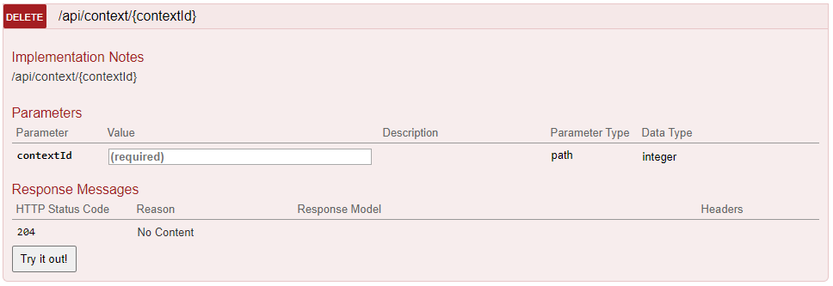  - Update context creation endpoints to ensure that determining if a context exists ignores contexts "marked as deleted":  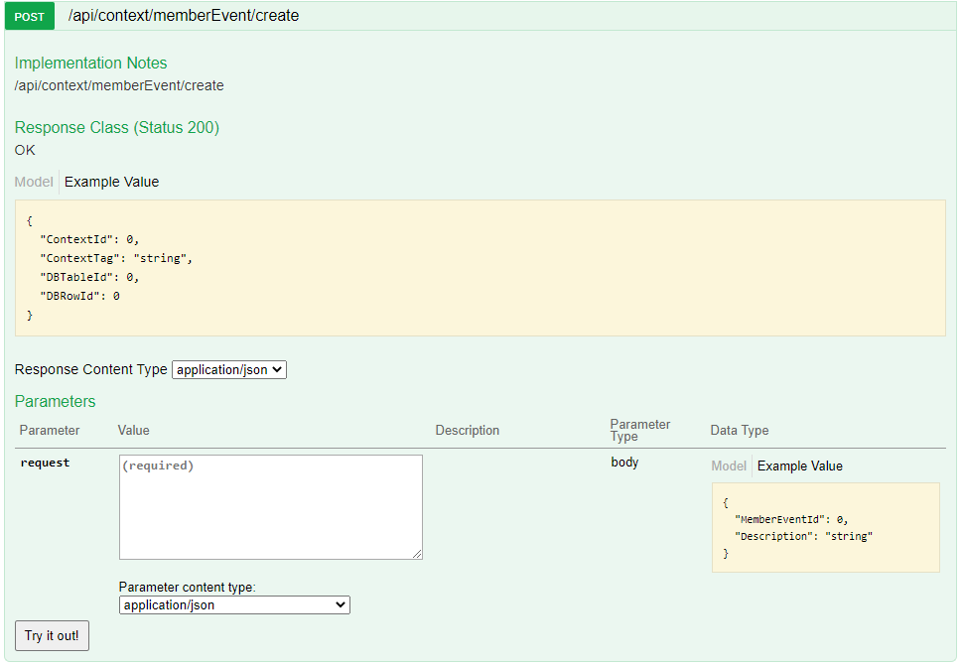  - Verified the usage of a context (ie, updating members, addresses, benefits, etc.) will fail if the context has been "marked as deleted".  - Updated member profile endpoint to prevent member events including contexts with a status of "marked as deleted":  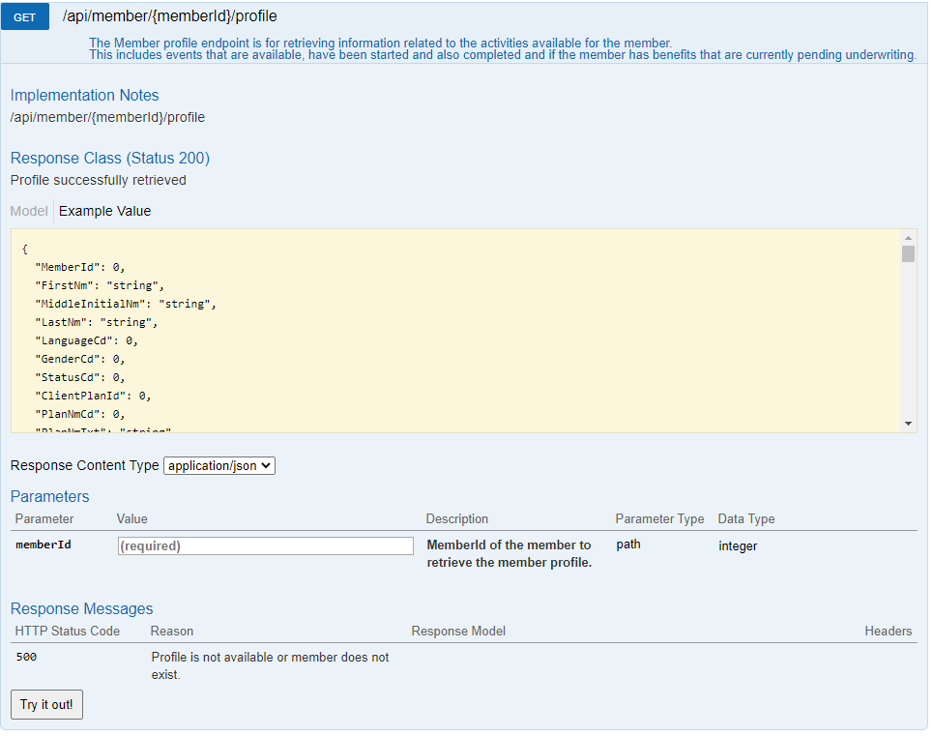
VO-2375 |  | Services | VoApi: Enhance Create Member Event to Create Api Context as well | Added optional parameter "createContext" to the MemberEvent post endpoint. This will create the context for the member event and return the context id and tag in the response.  **Swagger:**  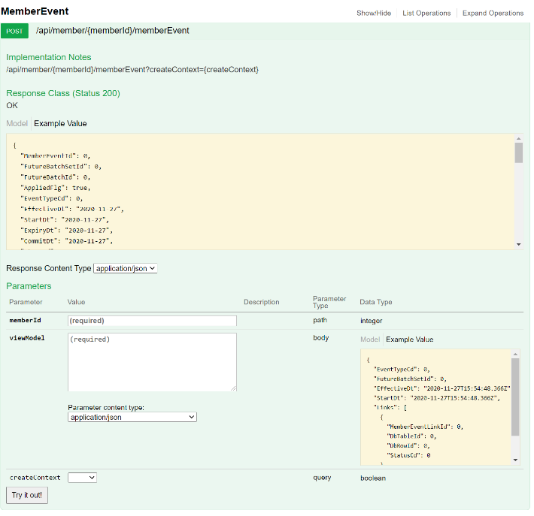  **Postman:**  